**Task 10 – Grade Remarks**

**Algorithm**

1. Get the score from the user using prompt().
2. Convert the score to a number using Number().
3. Use if-else-if-else statements to categorize:
   * 90–100: Excellent
   * 80–89: Very Good
   * 70–79: Good
   * 60–69: Pass
   * Below 60: Fail
4. Display result using both console.log() and alert().

**Psudocode**

START

PROMPT user for score (0–100)

CONVERT to number

DISPLAY entered score in console

IF score >= 90 AND score <= 100

DISPLAY "Excellent"

ELSE IF score >= 80

DISPLAY "Very Good"

ELSE IF score >= 70

DISPLAY "Good"

ELSE IF score >= 60

DISPLAY "Pass"

ELSE

DISPLAY "Fail"

END

**Code(javascript)  
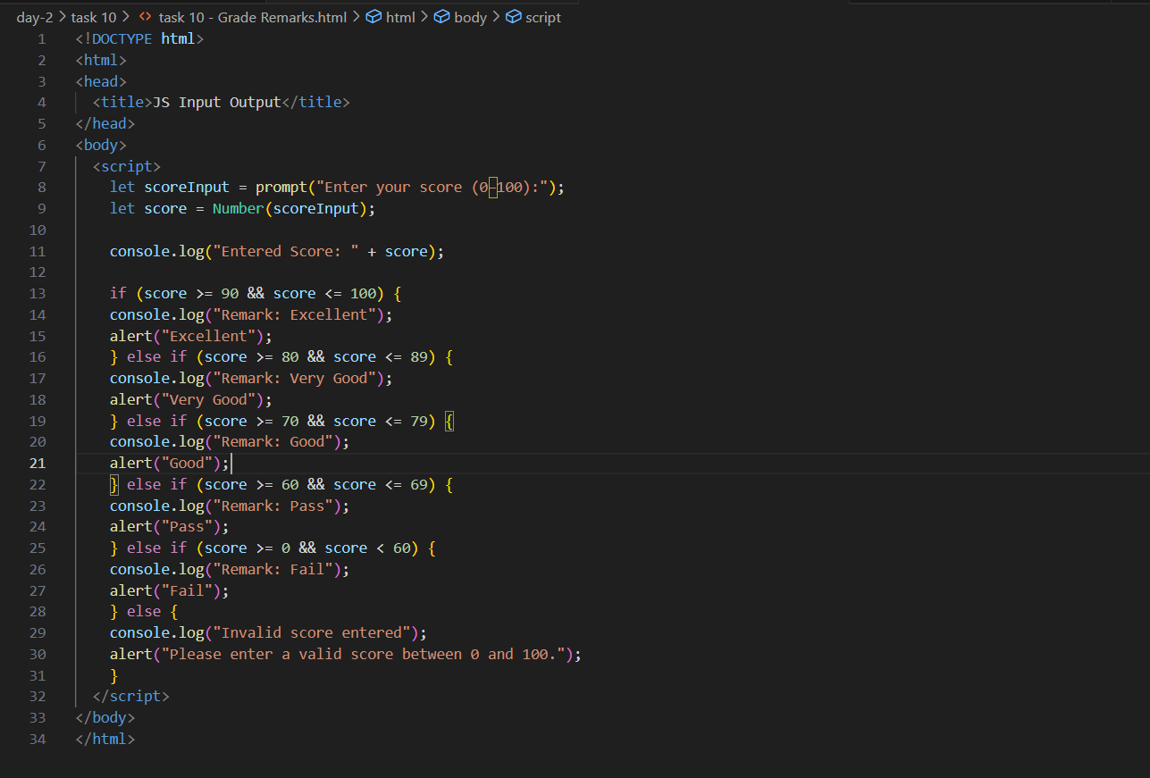**

**Output (test case 1)**

  
**Output (test case 2)**

  
**Output (test case 3)**



**Observations**• The program cleanly handles **score ranges** using if-else-if-else.

• Each range has a unique remark and all outputs are shown in both alert and console.

• Invalid input (e.g., score > 100 or < 0) is handled gracefully.